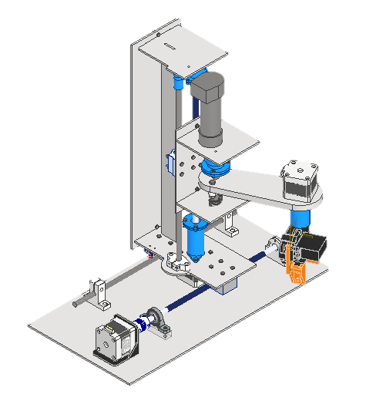

Mechatronics System Design

|  |  |
| --- | --- |
| Name | ID |
| Andrew Hany Sobhy | 1900440 |
| Abanoub Masrour Mehawed | 1901055 |
| Veronia Ibrahim Mikhael | 1900463 |
| John Sameh Sobhi | 1900907 |
| Caren Mahrous Zakhary | 1901503 |
| Zyad Wahied Kamel | 1700575 |

mechanical design report

submitted to:

**Eng. Hossam Elkeshky**

**Eng. Mohab Ahmed**

**Eng. Zeyad Hazem**

Contents

1. Robots in industrial field 4

2. What is a VDI model 4

1. System Requirements 5

2. System design 5

3. Domain specific design 6

1. Mechanical design 6

1. Joint #1 (Prismatic): 6

2. Joint #2 (Prismatic): 8

3. Joint #3 (Revolute): 9

4. Joint #4 (Revolute & End Effector): 11

5. Bill of material: 12

2. Actuator Sizing 13

1. Motor 1 13

2. Motor 2 15

3. Motor 3 17

3. Electrical design 19

1. PCB design 19

2. PID: 21

Tables of figures:

Figure 1 VDI model 4

Figure 2 joint 1 isometric view 6

Figure 3 joint 1 plan view. 6

Figure 4 joint 1 motion 6

Figure 5 joint 1 motor support floating bearing 6

Figure 6 joint 1 motor support fixed bearing 7

Figure 7 joint 2 front view 8

Figure 8 joint 2 side view 8

Figure 9 joint 2 isometric view 8

Figure 10 joint 2 motor support fixed bearing 9

Figure 11 joint 2 motor support floating bearing 9

Figure 12 joint 3 isometric view 9

Figure 13 joint 3 side view 9

Figure 14 joint 3 motor support fixed bearing 10

Figure 15 motor support floating bearing 10

Figure 16 joint 4 side view 11

Figure 17 joint 4 plan view 11

Figure 18 joint 4 motor support bearing 11

Figure 19: motor 1 in matlab view 13

Figure 20: Velocity Profile for motor 1 13

Figure 21: Connection configuration for motor 1 13

Figure 22: Torque Profile for motor 1 14

Figure 23: NEMA-17 Torque Speed characteristics 14

Figure 24: motor 2 in matlab view 15

Figure 25: motor 2 another view 15

Figure 26: Figure 27: Connection configuration for motor 2 16

Figure 28: Velocity Profile for motor 2 16

Figure 29: Torque Profile for motor 2 16

Figure 30: motor 3 in matlab view 17

Figure 31: motor 3 another view 17

Figure 32: Figure 33: Figure 34: Connection configuration for motor 2 18

Figure 35: Figure 36: Velocity Profile for motor 3 18

Figure 37 PCB layout 19

Figure 38 PCB 3d model 19

Figure 39 PCB schematic 20

Figure 40 PID using Simulink 21

Figure 41 Tuning PID 21

Figure 42 PID Block parameter 22

Figure 43 PID output curves ( position , speed) 22

Introduction

# Robots in industrial field

An industrial robot is an autonomous system of sensors, controllers, and actuators on an articulated frame that executes specific functions and operations in a manufacturing or processing line. They operate continuously through repetitive movement cycles as instructed by a set of commands called a program. These machines minimize or eliminate the human factor to gain various advantages in processing speed, capacity, and quality.

# Text Description automatically generated with low confidenceWhat is a VDI model

Figure VDI model

VDI Model

# System Requirements

1. The robot weight is less than 7.5 kg

2. size must not exceed 0.04 cubic meter

3. graphical user interface: user friendly

# System design

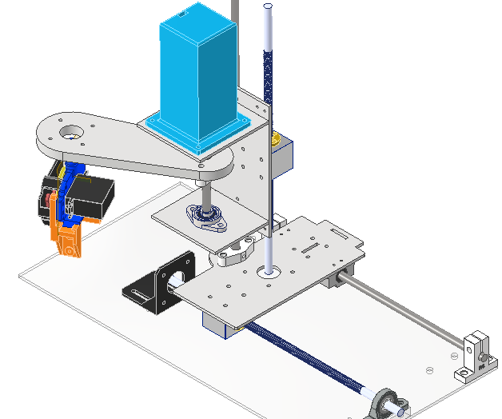For the system some decisions were taken according to the system requirements as

1. The 4 degrees of freedom will be divided into 2 prismatic joints (motion in x-axis , motion in z-axis) and 2 revolute joints (rotation about z-axis, rotation about end effector z-axis )
2. Application for robot is pick and place.
3. Number of motors 🡪 5
4. Dc motor with encoder for the revolute joint
5. 3 stepper motors
6. Servo motor for the end effector
7. A microcontroller is needed to control the motor and its motion. (Arduino)
8. Logo

   Description automatically generatedA PCB must be implemented to insure firm wiring.
9. Logo

   Description automatically generatedROS will be used as a communication protocol between microcontrollers and other electronic devices.

# Domain specific design

## Mechanical design

### Joint #1 (Prismatic):

* Diagram

  Description automatically generated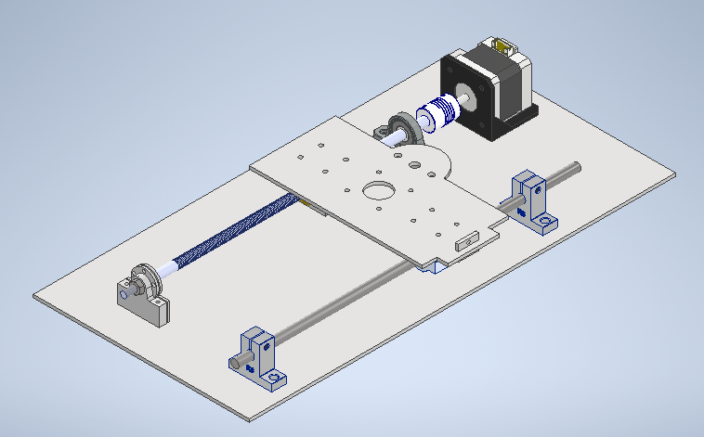Design:

Figure joint 1 isometric view

Figure joint 1 plan view.

* Operation and support:
* 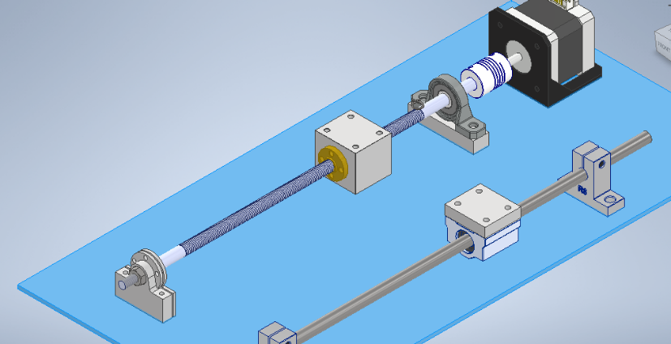Motion is Governed by a nema 17 motor coupled to a lead screw and guide nut to transform rotational motion into translational motion to carry the base in the Y Axis direction.

Figure joint 1 motion

* Bearings used : 3 ( 2 ball bearing , 1 linear bearing)
* 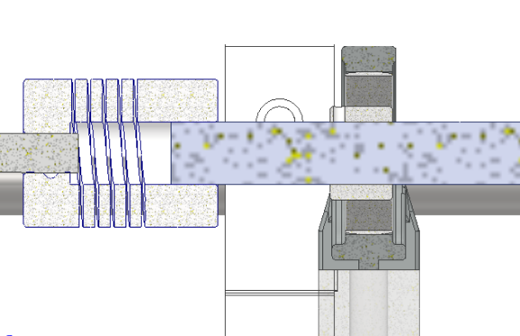Lead Screw and motor shaft are supported by 2 Plummer blocks at each end of the lead screw and the base is moved along a supporting rod attached jointed by a linear bearing.

Figure joint 1 motor support floating bearing

* Motor support:
  1. floating bearing:
* motion is transmitted to the lead screw using coupling between motor shaft and lead screw.
* Plummer block is used as the floating bearing.

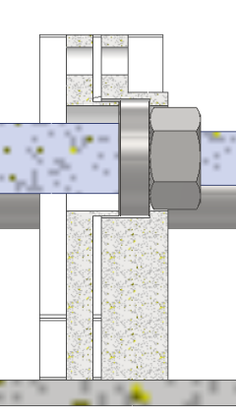

* 1. Fixed bearing:

Deep grove ball bearing fixed from 4 points ( shoulder

in lead screw, 2 shoulder in bearing cover, Nut)

Figure joint 1 motor support fixed bearing

### Joint #2 (Prismatic):

* 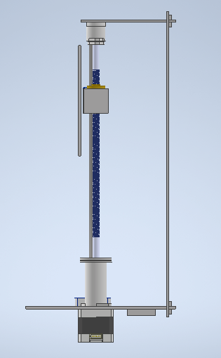Design:

Figure joint 2 front view

Figure joint 2 side view

Figure joint 2 isometric view

* Diagram, engineering drawing

  Description automatically generatedOperation and support

Motion is Governed by a nema 17 motor coupled to a lead screw and guide nut to transform rotational motion into translational motion to carry the Revolute joint in the Z Axis direction .

Revolute joint is attached to the cart by guide nut housing and Linear bearing block Via bolts and nuts , The cart is also supported on a linear rod.

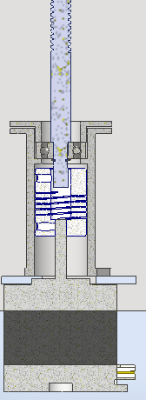

* Motor support
* Fixed

Deep Groove ball bearing Fixed on 4 points by ( Snap Ring , Housing shoulder, Power screw shoulder ,Cover)

Figure joint 2 motor support fixed bearing

* Floating

Deep Groove ball bearing Fixed on 2 points by (Housing Shoulder, Cover)

Figure joint 2 motor support floating bearing

### Joint #3 (Revolute):

* 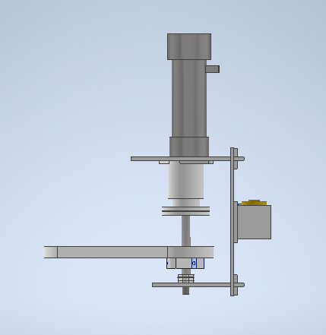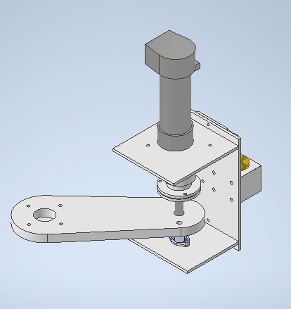Design:

Figure joint 3 isometric view

Figure joint 3 side view

* Operation and support:

Motion is Governed by a DC motor coupled to a rod and the rotation of rod is transferred to the joint by a pin connection to rotate around Z axis.

* A picture containing diagram

  Description automatically generatedMotor Support:
* Fixed

Deep Groove ball bearing Inside a flanged cover Fixed on 4 points by ( Nut, Housing shoulder, Power screw shoulder, Cover)

Figure joint 3 motor support fixed bearing

* Diagram, engineering drawing

  Description automatically generatedFloating

Figure motor support floating bearing

Deep Groove ball bearing Fixed on 2 points by (Housing Shoulder, Cover)

### Joint #4 (Revolute & End Effector):

* Design:

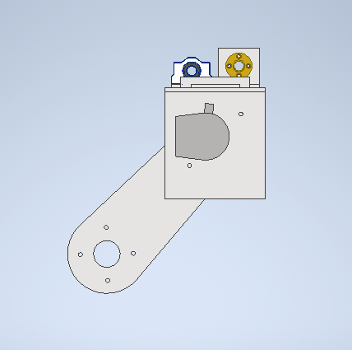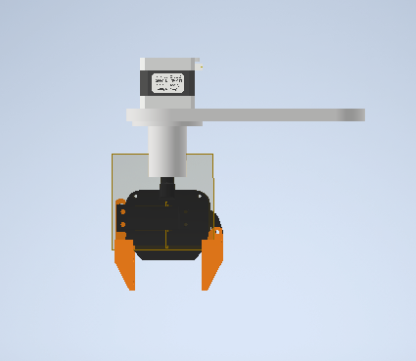

Figure joint 4 side view

Figure joint 4 plan view

* Operation and support:

Motion is Governed by a Nema 17 motor coupled to End Effector shaft to allow the end effector to rotate around Z axis .

End Effector has a servo motor attached to it to control the gripping action.

* 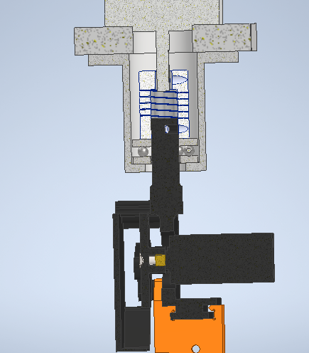Motor support:

Figure joint 4 motor support bearing

Thrust ball bearing Inside a cover fixed on 2 points by (Coupler, Housing shoulder)

### Bill of material:

|  |  |  |  |  |
| --- | --- | --- | --- | --- |
| component | qty | cost | store | specifications |
| lead screw | 2 | 60 | lancer | 30cm , 8mm |
| nut block | 2 | 70 | lancer | 8mm |
| lead screw nut | 2 | 30 | lancer | 2starts, 8mm |
| shaft | 3 | 40 | uge_helo. | 8mm * 333 length |
| linear bearing block | 2 | 50 | lancer | 8mm |
| vertical shaft support | 2 | 60 |  | 8mm , 3d printing |
| horizontal shaft support | 2 | 60 |  | 8mm , 3d printing |
| plumer block horizontal | 1 | 0 |  | 6mm , 3d printing |
| plumer block horizontal | 1 | 40 | lancer | 8mm |
| plumer block vertical | 1 | 0 |  | 6mm , 3d printing |
| Linear gripper | 1 | 0 |  | End Effector 3d printing |
| nema 17 holder | 1 | 40 |  |  |
| coupler 5*8 | 1 | 45 | lancer |  |
| coupler 6.35*10 | 1 | 70 | future | 10 OOS , 8 Available |
| nema 17 | 1 | 60 | lancer | used, 2 left |
| dc motor | 1 | 0 | john |  |
| Servo motor | 1 | 0 | caren |  |
| Nema 17 cable with Dupont | 1 | 20 | lancer |  |
| A4988 Driver | 1 | 50 | lancer | 2left |
| ball bearing (8*16) | 2 | 20 | twfi2ia | width 4 |
| ball bearing (6*13) | 1 | 20 | twfi2ia | width 3.5 |
| ball bearing (6*19) | 1 | 20 | twfi2ia | width 6 |
| thrust bearing (10*24) | 1 | 20 | twfi2ia | width 9 |
| snap ring | 1 | 0 |  | shaft 6 |
| bolts M4*1.6 | 8 | 1 | lancer |  |
| nema 17 screw set | 10 | 1 | lancer |  |
| bolts M3*1 | 8 | 1 | lancer |  |
| M6 nuts | 2 | 0 |  |  |

## Actuator Sizing

### Motor 1

Figure : motor 1 in matlab view

**Type**: Stepper motor (so we don’t need feedback or encoder to achieve accurate positioning with high torque)

**Inertia**:

**Motion Profile**:

Figure : Velocity Profile for motor 1

* max velocity = 300 rpm = 31.41 rad/s
* signal is in the form of trapezoidal pulses with acceleration time = 0.0077 seconds.

Figure : Connection configuration for motor 1

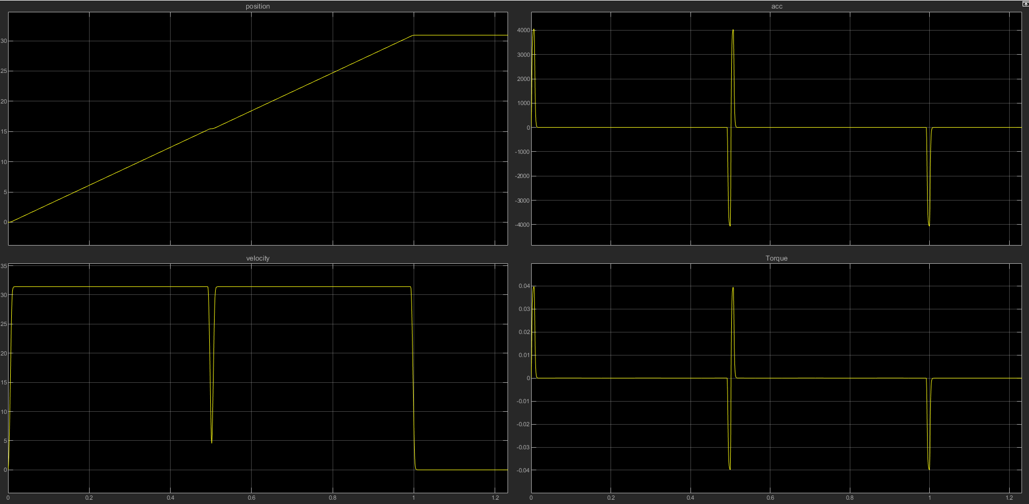

Figure : Torque Profile for motor 1

**Torque**: As we can see from the graph above the peak torque is at 0.04 N.m, one stepper motor that’s suitable for this torque at 300 rpm is the NEMA-17H2049-060-4A, which will provide a maximum speed of 300 rpm this gives us an acceleration time of 0.0077 seconds as mentioned above and the velocity profile matches exactly, except for the number of steps (pulses) given to the motor each second (2 steps are only demonstrated).

Figure : NEMA-17 Torque Speed characteristics

### Motor 2

Figure : motor 2 in matlab view

Figure : motor 2 another view

**Type**: Stepper motor (so we don’t need feedback or encoder to achieve accurate positioning with high torque)

**Inertia**:

**Motion Profile**:

* max velocity = 300 rpm = 31.41 rad/s
* 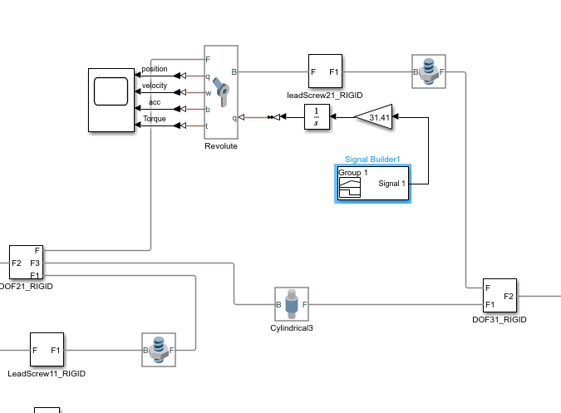signal is in the form of trapezoidal pulses with acceleration time = 0.01137 seconds.

Figure : Figure : Connection configuration for motor 2

Figure : Velocity Profile for motor 2

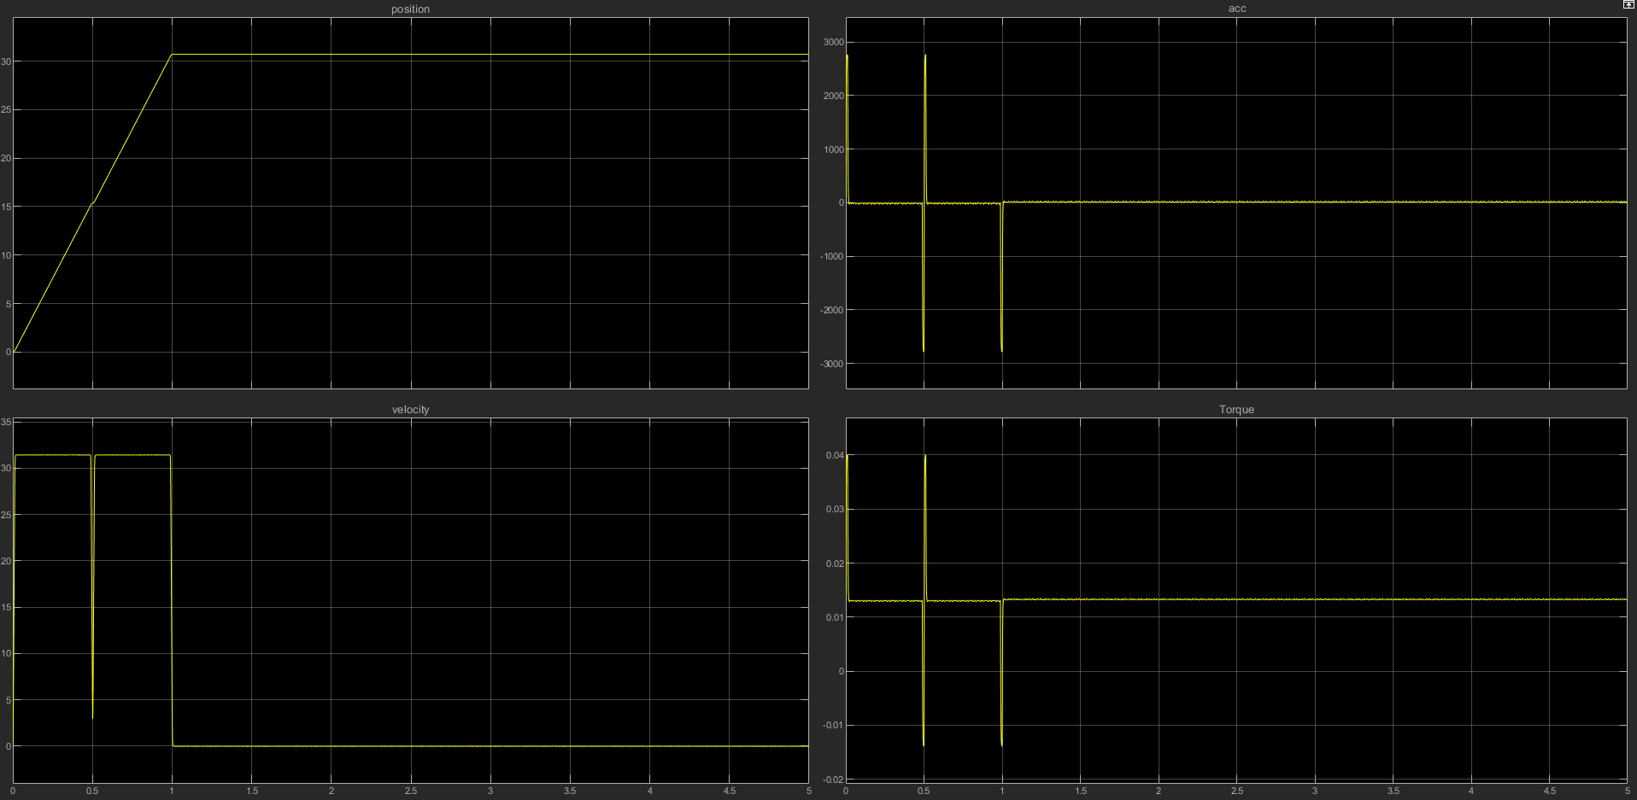

Figure : Torque Profile for motor 2

**Torque**: As we can see from the graph above the peak torque is at 0.04 N.m, at also 300 rpm this allows us to also use the NEMA-17 stepper motor as motor 1 (2 steps are only demonstrated in the above graph).

### A picture containing microscope Description automatically generatedMotor 3

Figure : motor 3 in matlab view

Figure : motor 3 another view

**Type**: Stepper motor (so we don’t need feedback or encoder to achieve accurate positioning with high torque)

**Inertia**:

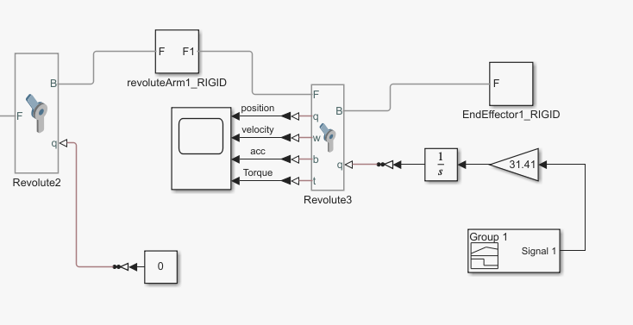**Motion Profile**:

Figure : Figure : Figure : Connection configuration for motor 2

* max velocity = 300 rpm = 31.41 rad/s
* signal is in the form of trapezoidal pulses with acceleration time = 0.07758 seconds.

Figure : Figure : Velocity Profile for motor 3

**Torque**: As we can see from the graph above the peak torque is at 0.04 N.m, at also 300 rpm this allows us to also use the NEMA-17 stepper motor as motors 1 and 2 (2 steps are only demonstrated in the above graph).

## Electrical design

### PCB design

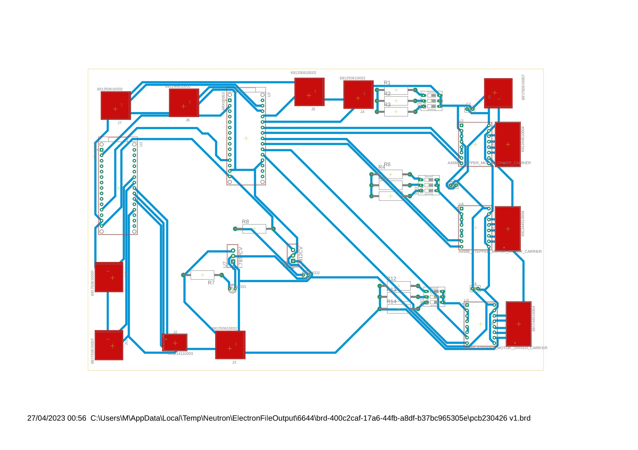

Figure PCB layout

Figure PCB 3d model

Figure PCB schematic

### Graphical user interface, application, table Description automatically generatedDiagram Description automatically generatedPID:

Figure PID using Simulink

Figure Tuning PID

Figure PID Block parameter

Figure PID output curves ( position , speed)